How to run JUnits

1.) Be sure you have JUnit installed. If you have Spring Tool Suite IDE, it is already included. Otherwise, download and make sure it is in your Build Path Libraries. (https://github.com/junit-team/junit/wiki/Download-and-Install)
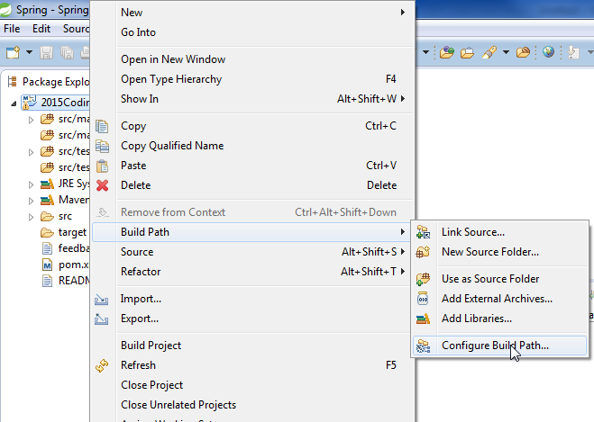
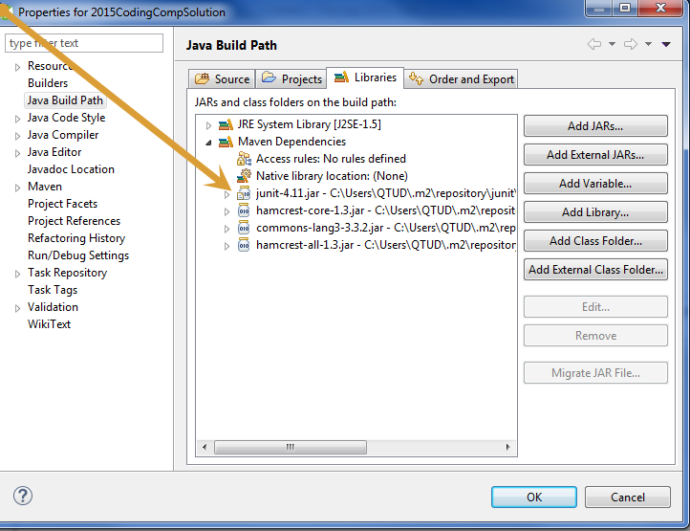
2.) Find location of JUnits (src/test/java) and right click RunAs Junit Test.
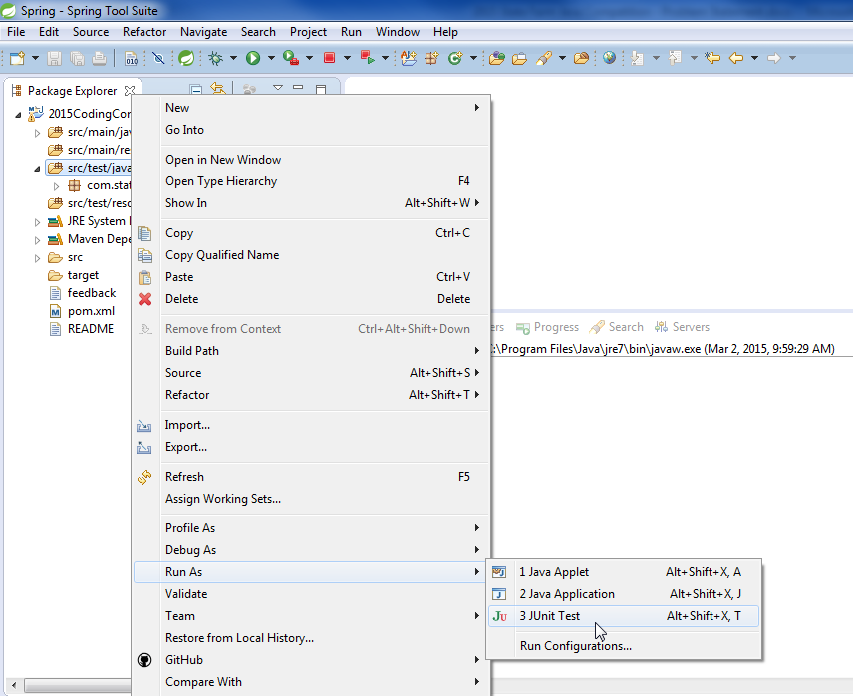
3.) See how many JUnits run cleanly and how many errors show up. 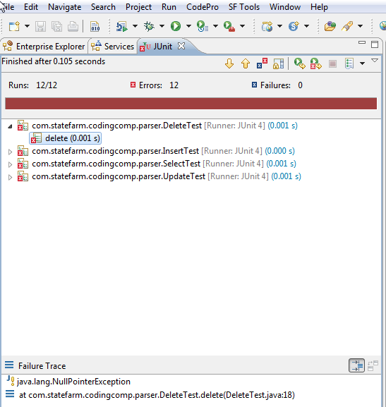
4. Repeat step 2 and step 3 until you have passed all JUnits.

